**Introduction to Human Computer Interaction (HCI)**

HCI (Human Computer Interaction) is a field of study that refers to communication between the human user and a computer system. Here interface refers to a medium or interaction between the computer and the end user. It is also known as CHI (Computer Human Interface) or MMI (Man Machine Interaction). It is concerned with design, evaluation, and implementation. It is used to provide a user-friendly environment.

Objective

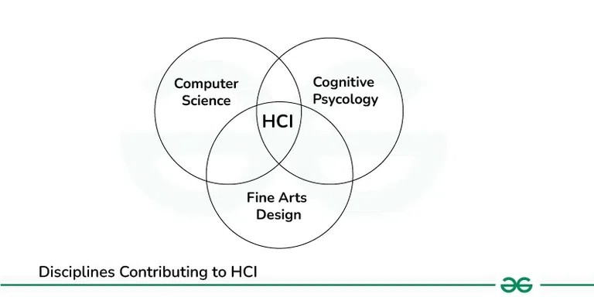

Human uses digital devices to perform various activities. HCI is to design a systems in such a way that make them efficient, stable, usable and attainable. Lack of communication can result in poor designed user interfaces. It provides a ways to reduce design time through various task models. There are some disciplines contributing to HCI.

**Disciplines-Contributing-to-HCI**

Computer Science

Computer science is a field of computation and information. Computer science plays a crucial role in modern development of HCI. Smart Television, Voice assistant, AR/VR technology and gaze detection are some of the technology exists in modern world, that are running our day to day life.

Cognitive Psychology

It is a field of HCI which identifies how human interact with systems. It includes Language based interaction, a set of rules are provided to the system. Based on that rules we create our model. It also includes Human motor skills, where we identifies physical characteristics of user and based on that characteristics we create our model.

Fine arts design

An artistic way of thinking always produce creative ideas. E-books and novels, digital drawings, video games are some of the applications of fine arts contributing to HCI.

**History**

Early computers was extremely difficult to use, it was large and expensive. It was used by specialists or engineers.

ENIAC (Electronic Numerical Integrator And Computer) was released in 1945. It was the first programmable electronic and general purpose digital computer.

In mid 1960‘s command line interface(CLI) was used to interact with computer. CLI are light weight and requires few memory consumption.

1980‘s are the booming phase for HCI. Some of the market leaders like Apple and Microsoft plays a crucial role for the modern development of HCI. GUI (Graphic User Interface) application was created that was easy to use, understand and visualize.

XEROX STAR was released in 1981. It had mouse driven graphical user interface and built-in ethernet network and protocol. It also had laser printer. This was considered far ahead of its time. Two years later in 1983 Apple Lisa was released, it offered document-centered graphical interface based on the metaphor of desktop.

In 1984 first Macintosh was release and it was revolutionary. It had good graphic user interface and a variety of fonts that makes your document more appealing to readers.

In 1990‘s internet starts it’s journey. Communication between people become very easy through social networking like Email. The World Wide Web(WWW) was created by Tim Berners-Lee. It is way for people to share information.

In 2000 mobile, laptop, tablet was a buzz word in this period. These gadget provides more flexibility to user. User can connect with anyone at any place. Smart phones comes into picture. User don’t need any mouse or pointing device to select anything. They can use their fingers to interact with device. It provides more features like built-in music player, camera, weather forecast, Internet, GPS, games, video conferencing and many more.

In 2006 NINTENDO released Wii. It was famous for it’s rear remote controller a handheld pointing device that detects movements in 3D. It enables users to simulate real world sports and activities through different games. This paved the way for gaming consoles like XBOX

Windows 10 is a series of operating systems developed by Microsoft released in 2015. It made user experience more consistent between different classes of device. The rising popularity and availability of laptops and computer systems, Microsoft made windows 10 adaptable into different systems.

VR oculus rift was a revolution in virtual reality. It was launched in 2016. The rift is primarily a gaming device. However it is also capable of viewing conventional movies and videos from inside the virtual cinema environment. It is increasingly used in universities and schools as an educational tool.

**Input and Output devices**

Input are actions received from user and output are the signals that sent back to user by system. It acts as a medium between computer and user. Some of the examples of input and output devices are as follows.

**Input devices**

Keyboard

Mouse

Light pen

Microphone

Bar code reader

**Output Devices**

Monitor

Television

Printer

Speakers

Headphones

**Interaction Styles**

Command Line : It is one of the oldest interaction style present today. But it is not user friendly because user needs to learn so many commands. Each task or work have it’s own command, you have to be expert or proficient in writing these commands.

Graphic user interface : It is one of the popular interaction style available today. Operating systems like Windows and macOS are the best style of GUI, where user can provide input with the help of mouse and keyboard.

Natural Language : It is one step ahead of GUI. We can interact with system by the help of languages that we are using in our day to day life. Alexa, Siri, Google voice are the best example of voice assistant that uses natural language.

Q/A (Question and Answer) : The best example of this interaction style are chatbots. Every application whether it is web or mobile application has chatbot now a days. But chatbots are always domain specific not universal.

**Use Cases of HCI**

Smart home : Smart homes refers to home amenities that have been fitted with communication technology enabling some degree of automation or remote control. It includes control of air conditioning, heating and lighting through voice activated commands or mobile app. Home security systems are also fitted with communication technology to alert the residents in case of burglary.

Biometric Sensors : Biometric sensors are the use of human biometrics in various technological applications. It can be used in access controls for example granting access to a computer network or security system.

Autonomous vehicle : An autonomous vehicle is one that can drive itself. Tesla is a company which pioneered the engineering of autonomous driving vehicles. It has advanced autopilot technology which allows real time navigation updates.

Virtual assistants : Another innovation in this era is the intelligent virtual assistant or intelligent personal assistant. It is a software agent that can perform task or services or an individual based on commands or questions. These virtual assistants can interpret human speech and respond via voices.

Smart phones for Visual Disabilities : There are some features present in smart phones that make the life of people with disabilities easy. Voiceover is a screen reader which basically means that your phone will talk out loud and tell you what’s on the screen. User can control it with certain touch gestures. There are some other features also like Magnification.

**Application of HCI in different domains**

It includes the design and development of application. These application includes desktop application, websites and mobile apps. These application are used in different domains it includes healthcare, banking, education, networking and many more.

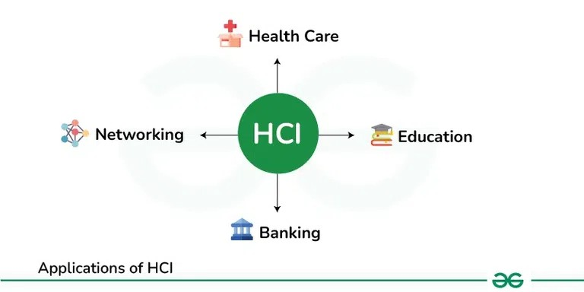

Health care

Patients have so many options now a days. They can buy medicines online and book appointments with doctor just with the help of mobile application. Augmented Reality(AR) and Virtual Reality(VR) are now transforming surgical process, previously it was very risky. Now doctor can use 3D animations to visualize the process. It can be used to train new surgeons.

Education

Now students can understand any concept more easily. There are so many resources available on internet now a days. Class room teaching are now very interesting with the help of smart classes. AR/VR can really help students to visualize any concept very easily. Students have option to study online. During COVID-19 students couldn’t able to go outside their home. In this situation they have option to study online.

Banking

Now common people don’t need to wait in long queues of bank. They can get banking solution right at their home using Net banking or Mobile banking. These application also provides user a secure environment to avoid cyber crimes.

Networking

Networking is very easy now a days. It includes social media networking and business networking. Now it is very easy for us to connect and share thoughts with anyone. It streamlines the process of finding jobs.

**Prototyping in Human-Computer Interaction(HCI)**

Prototyping is a fundamental practice in Human-Computer Interaction (HCI) that plays a crucial role in the design and development of digital products and systems. It involves creating early, scaled-down versions of a product to explore design ideas, test functionality, and gather feedback from users

**What is Prototyping in Human-Computer Interaction(HCI)?**

Prototyping in Human-Computer Interaction (HCI) refers to the process of creating a simplified, preliminary version of a digital product or system to gather feedback and test design concepts. Prototyping is an essential step in the iterative design process, allowing designers and developers to quickly explore ideas, refine interactions, and validate design decisions before investing in full-scale development.

**Objectives of Prototyping in Human-Computer Interaction(HCI)**

The main objectives of prototyping in Human-Computer Interaction (HCI) are:

Gather Feedback: Obtain early and continuous feedback from users to improve the design.

Test Design Concepts: Evaluate different design ideas and interactions to identify strengths and weaknesses.

Refine Interaction Design: Iterate on the design to enhance usability, functionality, and user satisfaction.

Validate Design Decisions: Confirm that the design meets user needs and aligns with project goals.

Improve Communication: Facilitate communication between stakeholders, designers, and developers by visualizing design concepts.

Reduce Development Risks: Identify and address potential issues early in the design process to minimize risks during development.

**Why we need Prototyping in Human-Computer Interaction(HCI)?**

User Feedback: Prototyping allows designers to gather feedback from users early in the design process. This feedback is crucial for understanding user needs, preferences, and pain points, which can inform and improve the final design.

Visualization: Prototyping helps designers and stakeholders visualize and interact with the design concept. It provides a tangible representation of the proposed solution, making it easier to evaluate and refine ideas.

Iterative Design: Prototyping supports an iterative design process, where designers can quickly create, test, and refine design ideas. This iterative approach leads to more user-centered and effective designs.

Risk Reduction: By testing design concepts early with prototypes, designers can identify and address potential issues before investing in full-scale development. This reduces the risk of developing a product that does not meet user needs or expectations.

Communication: Prototypes serve as a communication tool between designers, developers, and stakeholders. They help convey design ideas, demonstrate interactions, and gather feedback more effectively than verbal or written descriptions.

Cost-Effective: Prototyping is often more cost-effective than developing a fully functional product. It allows designers to explore multiple design alternatives and make informed decisions without the expense of full-scale development.

**Types of Prototyping in Human-Computer Interaction(HCI)**

In Human-Computer Interaction (HCI), there are several types of prototyping, including low-fidelity, medium-fidelity, and high-fidelity prototypes. Each type offers a different level of detail and functionality, allowing designers to explore, test, and refine their design ideas at various stages of the design process.

1. Low-Fidelity Prototyping in Human-Computer Interaction(HCI)

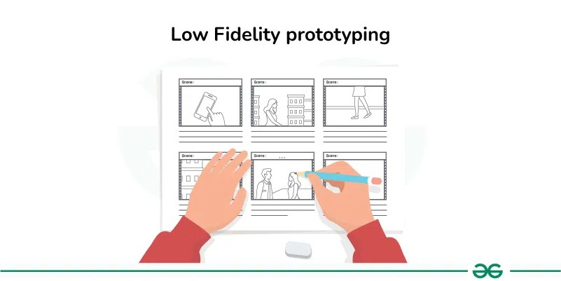

Unified Modeling Language (UML) Diagrams

Prototyping Model - Software Engineering

Prototyping in Human-Computer Interaction(HCI)

Last Updated : 19 Feb, 2024

Prototyping is a fundamental practice in Human-Computer Interaction (HCI) that plays a crucial role in the design and development of digital products and systems. It involves creating early, scaled-down versions of a product to explore design ideas, test functionality, and gather feedback from users

HCI

**What is Prototyping in Human-Computer Interaction(HCI)?**

Prototyping in Human-Computer Interaction (HCI) refers to the process of creating a simplified, preliminary version of a digital product or system to gather feedback and test design concepts. Prototyping is an essential step in the iterative design process, allowing designers and developers to quickly explore ideas, refine interactions, and validate design decisions before investing in full-scale development.

**Objectives of Prototyping in Human-Computer Interaction(HCI)**

The main objectives of prototyping in Human-Computer Interaction (HCI) are:

Gather Feedback: Obtain early and continuous feedback from users to improve the design.

Test Design Concepts: Evaluate different design ideas and interactions to identify strengths and weaknesses.

Refine Interaction Design: Iterate on the design to enhance usability, functionality, and user satisfaction.

Validate Design Decisions: Confirm that the design meets user needs and aligns with project goals.

Improve Communication: Facilitate communication between stakeholders, designers, and developers by visualizing design concepts.

Reduce Development Risks: Identify and address potential issues early in the design process to minimize risks during development.

**Why we need Prototyping in Human-Computer Interaction(HCI)?**

User Feedback: Prototyping allows designers to gather feedback from users early in the design process. This feedback is crucial for understanding user needs, preferences, and pain points, which can inform and improve the final design.

Visualization: Prototyping helps designers and stakeholders visualize and interact with the design concept. It provides a tangible representation of the proposed solution, making it easier to evaluate and refine ideas.

Iterative Design: Prototyping supports an iterative design process, where designers can quickly create, test, and refine design ideas. This iterative approach leads to more user-centered and effective designs.

Risk Reduction: By testing design concepts early with prototypes, designers can identify and address potential issues before investing in full-scale development. This reduces the risk of developing a product that does not meet user needs or expectations.

Communication: Prototypes serve as a communication tool between designers, developers, and stakeholders. They help convey design ideas, demonstrate interactions, and gather feedback more effectively than verbal or written descriptions.

Cost-Effective: Prototyping is often more cost-effective than developing a fully functional product. It allows designers to explore multiple design alternatives and make informed decisions without the expense of full-scale development.

**Types of Prototyping in Human-Computer Interaction(HCI)**

In Human-Computer Interaction (HCI), there are several types of prototyping, including low-fidelity, medium-fidelity, and high-fidelity prototypes. Each type offers a different level of detail and functionality, allowing designers to explore, test, and refine their design ideas at various stages of the design process.

**1. Low-Fidelity Prototyping in Human-Computer Interaction(HCI)**

l

Low-fidelity prototypes are quick and easy to create, often using simple tools like paper, markers, or digital wireframing software.

These prototypes focus on conveying basic design concepts and interactions without getting into detailed visuals or functionality.

Low-fidelity prototypes are ideal for early-stage ideation, allowing designers to quickly explore and iterate on ideas, gather feedback from users, and test basic interactions.

They are cost-effective and accessible to both designers and non-designers, making them a valuable tool for brainstorming and concept validation.

For example:

A paper sketch of the app’s main screens, showing basic layout and navigation.

**When to use Low-Fidelity Prototyping?**

Use when exploring and brainstorming initial design concepts.

Use to gather quick feedback and validate basic ideas.

Use in the early stages of the design process to iterate rapidly and explore different design directions.

Use when time and resources are limited.

2**. Medium-Fidelity Prototyping in Human-Computer Interaction(HCI)**

Medium-fidelity prototypes are more detailed than low-fidelity prototypes but less polished than high-fidelity prototypes.

It’s not as basic as a simple drawing, but it’s also not as fancy as a fully finished product.

Medium-fidelity prototypes are used to test more complex interactions, gather more detailed feedback from users, and validate design decisions.

They offer a balance between detail and speed, allowing designers to explore design ideas in more depth without investing too much time or resources

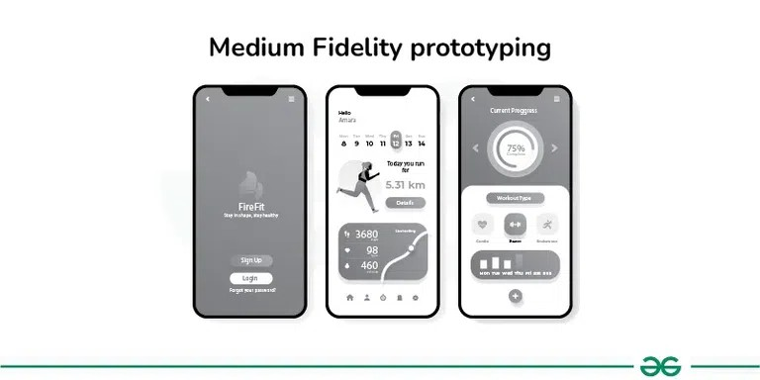

For example:

More detailed screens with basic interactive elements like buttons and links, but without actual content or graphics.

**When to use Medium-Fidelity Prototyping?**

Use when you need to test more detailed interactions and user flows.

Use to refine the layout, navigation, and visual hierarchy of your design.

Use when you want to involve stakeholders in more detailed design discussions.

Use when you have more time and resources to create a more polished prototype.

**3. High-Fidelity Prototyping in Human-Computer Interaction(HCI)**

**Prototyping in Human-Computer Interaction(HCI)**

Prototyping is a fundamental practice in Human-Computer Interaction (HCI) that plays a crucial role in the design and development of digital products and systems. It involves creating early, scaled-down versions of a product to explore design ideas, test functionality, and gather feedback from users

**What is Prototyping in Human-Computer Interaction(HCI)?**

**P**rototyping in Human-Computer Interaction (HCI) refers to the process of creating a simplified, preliminary version of a digital product or system to gather feedback and test design concepts. Prototyping is an essential step in the iterative design process, allowing designers and developers to quickly explore ideas, refine interactions, and validate design decisions before investing in full-scale development.

**Objectives of Prototyping in Human-Computer Interaction(HCI)**

**The main objectives of prototyping in Human-Computer Interaction (HCI) are:**

Gather Feedback: Obtain early and continuous feedback from users to improve the design.

Test Design Concepts: Evaluate different design ideas and interactions to identify strengths and weaknesses.

Refine Interaction Design: Iterate on the design to enhance usability, functionality, and user satisfaction.

Validate Design Decisions: Confirm that the design meets user needs and aligns with project goals.

I**mprove Communication: Facilitate communication between stakeholders, designers, and developers by visualizing design concepts.**

**Reduce Development Risks: Identify and address potential issues early in the design process to minimize risks during development.**

**Why we need Prototyping in Human-Computer Interaction(HCI)?**

**U**ser Feedback: Prototyping allows designers to gather feedback from users early in the design process. This feedback is crucial for understanding user needs, preferences, and pain points, which can inform and improve the final design.

Visualization: Prototyping helps designers and stakeholders visualize and interact with the design concept. It provides a tangible representation of the proposed solution, making it easier to evaluate and refine ideas.

Iterative Design: Prototyping supports an iterative design process, where designers can quickly create, test, and refine design ideas. This iterative approach leads to more user-centered and effective designs.

**R**isk Reduction: By testing design concepts early with prototypes, designers can identify and address potential issues before investing in full-scale development. This reduces the risk of developing a product that does not meet user needs or expectations.

Communication: Prototypes serve as a communication tool between designers, developers, and stakeholders. They help convey design ideas, demonstrate interactions, and gather feedback more effectively than verbal or written descriptions.

Cost-Effective: Prototyping is often more cost-effective than developing a fully functional product. It allows designers to explore multiple design alternatives and make informed decisions without the expense of full-scale development.

Types of Prototyping in Human-Computer Interaction(HCI)

In Human-Computer Interaction (HCI), there are several types of prototyping, including low-fidelity, medium-fidelity, and high-fidelity prototypes. Each type offers a different level of detail and functionality, allowing designers to explore, test, and refine their design ideas at various stages of the design process.

**1. Low-Fidelity Prototyping in Human-Computer Interaction(HCI)**

**l**

Low-fidelity prototypes are quick and easy to create, often using simple tools like paper, markers, or digital wireframing software.

These prototypes focus on conveying basic design concepts and interactions without getting into detailed visuals or functionality.

Low-fidelity prototypes are ideal for early-stage ideation, allowing designers to quickly explore and iterate on ideas, gather feedback from users, and test basic interactions.

They are cost-effective and accessible to both designers and non-designers, making them a valuable tool for brainstorming and concept validation.

**For example:**

**A paper sketch of the app’s main screens, showing basic layout and navigation.**

**When to use Low-Fidelity Prototyping?**

**U**se when exploring and brainstorming initial design concepts.

Use to gather quick feedback and validate basic ideas.

Use in the early stages of the design process to iterate rapidly and explore different design directions.

Use when time and resources are limited.

**2. Medium-Fidelity Prototyping in Human-Computer Interaction(HCI)**

**m**

Medium-fidelity prototypes are more detailed than low-fidelity prototypes but less polished than high-fidelity prototypes.

It’s not as basic as a simple drawing, but it’s also not as fancy as a fully finished product.

Medium-fidelity prototypes are used to test more complex interactions, gather more detailed feedback from users, and validate design decisions.

They offer a balance between detail and speed, allowing designers to explore design ideas in more depth without investing too much time or resources.

For example:

More detailed screens with basic interactive elements like buttons and links, but without actual content or graphics.

**When to use Medium-Fidelity Prototyping?**

**U**se when you need to test more detailed interactions and user flows.

Use to refine the layout, navigation, and visual hierarchy of your design.

Use when you want to involve stakeholders in more detailed design discussions.

Use when you have more time and resources to create a more polished prototype.

**3. High-Fidelity Prototyping in Human-Computer Interaction(HCI)**

**H**igh-fidelity prototyping is like creating a highly detailed and realistic version of your design idea. It closely resembles the final product in terms of appearance and functionality, but it’s not fully functional.

In a high-fidelity prototype, you would use software tools to create a digital version of your design that looks and behaves almost like the real thing.

While high-fidelity prototypes require more time and resources to create, they offer a more accurate representation of the final product, making them valuable for testing complex interactions and gathering detailed feedback from users.

**For example:**

Fully designed screens with realistic content, graphics, and interactive elements that closely resemble the final app.

**When to use High-Fidelity Prototyping?**

Use when you need to conduct realistic usability testing.

Use to present a more polished and detailed version of your design to stakeholders.

Use when you want to simulate the final product as closely as possible.

Use when you are ready to finalize the design and move into development.

**Example of Prototyping in Human-Computer Interaction(HCI)**

An example of prototyping in HCI is the design of a new mobile app

**Low-Fidelity Prototype**

Designers create rough sketches on paper showing different screens and basic interactions of the app.

Why?: To quickly explore and iterate on different layout and interaction ideas, gather initial feedback from users.

**Medium-Fidelity Prototype:**

Designers use digital tools to create wireframes of the app, showing more detailed layouts and interactions.

Why?: To test and refine the user flow, navigation, and overall usability of the app.

**High-Fidelity Prototype:**

Designers create a digital prototype of the app that closely resembles the final product, including realistic graphics and interactive elements.

Why?: To conduct usability testing with users, validate design decisions, and provide stakeholders with a realistic preview of the app.

**Differences between Low-Fidelity and High-Fidelity Prototyping in HCI**

Below are the differences between Low and High-fidelity prototyping in Human Computer Interaction(HCI):

|  |  |  |  |
| --- | --- | --- | --- |
| **S/N** | **Aspect** | **Low-Fidelity Prototyping** | **High-Fidelity Prototyping** |
| **1** | **Fidelity** | **Simple, basic representations (e.g., sketches, wireframes)** | **Detailed, realistic representations (e.g., interactive prototypes with graphics)** |
| **2** | **Cost** | **Low cost, as they can be created quickly and with minimal resources** | **Higher cost, as they require more time and resources to create** |
| **3** | **Speed** | **Quick to create and iterate on** | **Slower to create and iterate on** |
| **4** | **Usability testing** | **Suitable for early-stage testing and feedback gathering** | **Suitable for detailed usability testing and validation** |
| **5** | **Realism** | **Less realistic, focusing on concept exploration** | **More realistic, resembling the final product** |
| **6** | **Functionality** | **Limited functionality, primarily focusing on key interactions** | **May include more functionality to mimic the final product** |
| **7** | **Stake holder**  **Engagement** | **Effective for early stakeholder communication and idea validation** | **More engaging for stakeholders and clients due to realistic representation** |
| **8** | **Development guadiance** | **Provides a general direction for development** | **Offers more specific guidance for development** |

**Differences between Medium-Fidelity and High-Fidelity Prototyping in HCI**

**Below are the differences between Medium and High-fidelity prototyping in Human Computer Interaction(HCI):**

|  |  |  |  |
| --- | --- | --- | --- |
| **S/N** | **Aspect** | **Medium-Fidelity Prototyping High-Fidelity** | **High-Fidelity Prototyping High-Fidelity** |
| **1** | **Fidelity** | **More detailed than low-fidelity, but less polished than high-fidelity** | **Very detailed, closely resembling the final product** |
| **2** | **Cost** | **Moderate cost, as they require more time and resources than low-fidelity** | **Higher cost, as they require more time and resources to create** |
| **3** | **Speed** | **Moderate speed, more time needed for details and refinement** | **Slower, more time-consuming due to detailed design elements** |
| **4** | **Usability testing** | **More suitable for detailed usability testing and feedback** | **Ideal for realistic usability testing and user engagement** |
| **5** | **Realism** | **Includes some visual and interactive elements** | **Includes detailed visual and interactive elements** |
| **6** | **Stakeholder engagement** | **Suitable for presenting to stakeholders and refining design ideas** | **Ideal for presentations and demonstrations to stakeholders** |
| **7** | **Iteration** | **Allows for some iteration and changes based on feedback** | **Slower iteration due to complexity of design elements** |

**What is Interaction Design Process?**

**U**ser-centric digital experiences are built on interaction design, which facilitates smooth interactions between people and technology. Designers unearth user demands and behaviors through painstaking research and analysis, which paves the way for intuitive interface design. In order to create interfaces that feel intuitive and natural, designers must anticipate user actions and preferences, which requires a high degree of empathy. Iterative testing and prototyping improve designs, guaranteeing their efficacy and usability. AI and AR are examples of emerging technologies that open up new interface design possibilities. Empirical instances demonstrate how careful design affects user happiness and corporate performance. Everyday digital encounters are shaped by interaction design, from smart devices to smartphone apps. Being an expert in interface design is crucial to producing engaging user experiences in a cutthroat market. Come explore the ideas and methods underlying this revolutionary discipline with us.

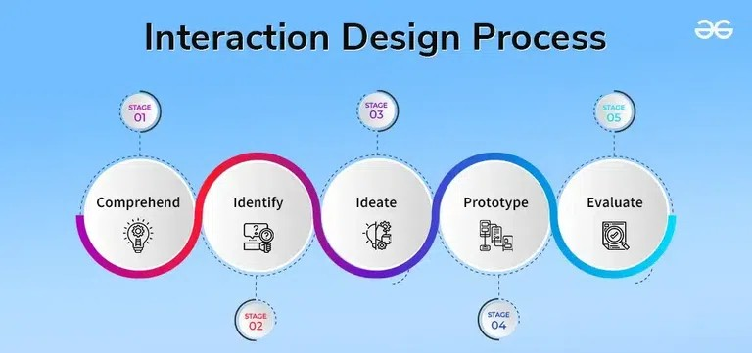

**What is Interaction Design Process?**

**User-centric digital experiences are built on interaction design, which facilitates smooth interactions between people and technology. Designers unearth user demands and behaviors through painstaking research and analysis, which paves the way for intuitive interface design. In order to create interfaces that feel intuitive and natural, designers must anticipate user actions and preferences, which requires a high degree of empathy. Iterative testing and prototyping improve designs, guaranteeing their efficacy and usability. AI and AR are examples of emerging technologies that open up new interface design possibilities. Empirical instances demonstrate how careful design affects user happiness and corporate performance. Everyday digital encounters are shaped by interaction design, from smart devices to smartphone apps. Being an expert in interface design is crucial to producing engaging user experiences in a cutthroat market. Come explore the ideas and methods underlying this revolutionary discipline with us.**

**Interaction Design Process**

**The 5 Stages of the Interaction Design Process**

**A better understanding of these steps can lead to the development of products that are easier to use and more intuitive. The five steps that are often included in the interaction design process are as follows:**

**1.)Comprehend:**

**During this stage of research, designers aim to comprehend the requirements, incentives, and actions of users. It entails getting information by means of surveys, observations, interviews, and data analysis on previously collected information. The objective is to uncover design possibilities or difficulties and to feel empathy for the users.**

**2.)Identify:**

**At this phase, designers combine the study results to identify the main issues that need to be resolved. In order to illustrate the essential characteristics of the target audience and their context, personas, user stories, and scenarios are frequently created. It is easier to concentrate design efforts on the aspects that are most important to users when the challenge is well defined.**

**3.)Ideate:**

**During the ideation phase, designers generate a wide range of innovative ideas after having a firm grasp of the user requirements and identified difficulties. Methods like thought mapping, wireframing, drawing, and prototyping are employed to investigate various ideas and strategies. The goal is to provide a wide range of concepts that may be honed and focused on later.**

**4.)Prototype:**

**In order to test a product with users, simplified versions must be created. These prototypes might be as simple as wireframes or low-fidelity drawings or as complex as interactive models. In order to test and improve design concepts and enable designers to swiftly iterate depending on feedback, prototyping is essential.**

**5.)Evaluate:**

**In the last phase, real users test the prototypes and design concepts to get their opinions on usability, efficacy, and overall experience. Surveys, interviews, and usability testing can all be used for this. The product is further refined using the insights gathered from this stage, starting an iteration cycle that lasts until the design satisfies the needs and expectations of the users.**

**What is Interaction Design Process?**

**User-centric digital experiences are built on interaction design, which facilitates smooth interactions between people and technology. Designers unearth user demands and behaviors through painstaking research and analysis, which paves the way for intuitive interface design. In order to create interfaces that feel intuitive and natural, designers must anticipate user actions and preferences, which requires a high degree of empathy. Iterative testing and prototyping improve designs, guaranteeing their efficacy and usability. AI and AR are examples of emerging technologies that open up new interface design possibilities. Empirical instances demonstrate how careful design affects user happiness and corporate performance. Everyday digital encounters are shaped by interaction design, from smart devices to smartphone apps. Being an expert in interface design is crucial to producing engaging user experiences in a cutthroat market. Come explore the ideas and methods underlying this revolutionary discipline with us.**

**Interaction Design Process**

**Interaction Design Process**

**The 5 Stages of the Interaction Design Process**

**A better understanding of these steps can lead to the development of products that are easier to use and more intuitive. The five steps that are often included in the interaction design process are as follows:**

**1.)Comprehend:**

**During this stage of research, designers aim to comprehend the requirements, incentives, and actions of users. It entails getting information by means of surveys, observations, interviews, and data analysis on previously collected information. The objective is to uncover design possibilities or difficulties and to feel empathy for the users.**

**2.)Identify:**

**At this phase, designers combine the study results to identify the main issues that need to be resolved. In order to illustrate the essential characteristics of the target audience and their context, personas, user stories, and scenarios are frequently created. It is easier to concentrate design efforts on the aspects that are most important to users when the challenge is well defined.**

**3.)Ideate:**

**During the ideation phase, designers generate a wide range of innovative ideas after having a firm grasp of the user requirements and identified difficulties. Methods like thought mapping, wireframing, drawing, and prototyping are employed to investigate various ideas and strategies. The goal is to provide a wide range of concepts that may be honed and focused on later.**

**4.)Prototype:**

**In order to test a product with users, simplified versions must be created. These prototypes might be as simple as wireframes or low-fidelity drawings or as complex as interactive models. In order to test and improve design concepts and enable designers to swiftly iterate depending on feedback, prototyping is essential.**

**5.)Evaluate:**

**In the last phase, real users test the prototypes and design concepts to get their opinions on usability, efficacy, and overall experience. Surveys, interviews, and usability testing can all be used for this. The product is further refined using the insights gathered from this stage, starting an iteration cycle that lasts until the design satisfies the needs and expectations of the users.**

**What is Interaction Design Process?**

**User-centric digital experiences are built on interaction design, which facilitates smooth interactions between people and technology. Designers unearth user demands and behaviors through painstaking research and analysis, which paves the way for intuitive interface design. In order to create interfaces that feel intuitive and natural, designers must anticipate user actions and preferences, which requires a high degree of empathy. Iterative testing and prototyping improve designs, guaranteeing their efficacy and usability. AI and AR are examples of emerging technologies that open up new interface design possibilities. Empirical instances demonstrate how careful design affects user happiness and corporate performance. Everyday digital encounters are shaped by interaction design, from smart devices to smartphone apps. Being an expert in interface design is crucial to producing engaging user experiences in a cutthroat market. Come explore the ideas and methods underlying this revolutionary discipline with us.**

**Interaction Design Process**

**Interaction Design Process**

**The 5 Stages of the Interaction Design Process**

**A better understanding of these steps can lead to the development of products that are easier to use and more intuitive. The five steps that are often included in the interaction design process are as follows:**

**1.)Comprehend:**

**During this stage of research, designers aim to comprehend the requirements, incentives, and actions of users. It entails getting information by means of surveys, observations, interviews, and data analysis on previously collected information. The objective is to uncover design possibilities or difficulties and to feel empathy for the users.**

**2.)Identify:**

**At this phase, designers combine the study results to identify the main issues that need to be resolved. In order to illustrate the essential characteristics of the target audience and their context, personas, user stories, and scenarios are frequently created. It is easier to concentrate design efforts on the aspects that are most important to users when the challenge is well defined.**

**3.)Ideate:**

**During the ideation phase, designers generate a wide range of innovative ideas after having a firm grasp of the user requirements and identified difficulties. Methods like thought mapping, wireframing, drawing, and prototyping are employed to investigate various ideas and strategies. The goal is to provide a wide range of concepts that may be honed and focused on later.**

**4.)Prototype:**

**In order to test a product with users, simplified versions must be created. These prototypes might be as simple as wireframes or low-fidelity drawings or as complex as interactive models. In order to test and improve design concepts and enable designers to swiftly iterate depending on feedback, prototyping is essential.**

**5.)Evaluate:**

**In the last phase, real users test the prototypes and design concepts to get their opinions on usability, efficacy, and overall experience. Surveys, interviews, and usability testing can all be used for this. The product is further refined using the insights gathered from this stage, starting an iteration cycle that lasts until the design satisfies the needs and expectations of the users.**

**What are the Uses?**

**The Interaction Design method has undoubtedly been applied in the following five ways:**

**1. Website Design and Development:**

**The concepts of interaction design are essential to the creation of user-friendly, easily navigable websites that improve user experience by directing users to the content or activities they want to do.**

**2. Mobile Applications:**

**Interaction design makes sure that apps are made to be intuitive and effective on smaller screens by optimizing them for touch-based navigation.**

**3. Software Applications:**

**Through thoughtfully created user interfaces, interaction design for desktop and corporate software streamlines intricate procedures and helps users complete tasks more quickly.**

**4. Wearable Technology:**

**A key component of wearable technology is interaction design, which focuses on developing user-friendly interfaces in constrained areas and highlights important data and interactions for users to utilize while on the go.**

**5. IoT and Smart Home Devices:**

**In the field of IoT and smart home devices, interaction design makes it easier for users to control complicated systems with basic interactions. These interactions frequently incorporate voice commands, gestures, or simple touch inputs.**

**Benefits of Interaction Design Process following five ways:**

**1. Website Design and Development:**

**The concepts of interaction design are essential to the creation of user-friendly, easily navigable websites that improve user experience by directing users to the content or activities they want to do.**

**2. Mobile Applications:**

**Interaction design makes sure that apps are made to be intuitive and effective on smaller screens by optimizing them for touch-based navigation.**

**3. Software Applications:**

**Through thoughtfully created user interfaces, interaction design for desktop and corporate software streamlines intricate procedures and helps users complete tasks more quickly.**

**4. Wearable Technology:**

**A key component of wearable technology is interaction design, which focuses on developing user-friendly interfaces in constrained areas and highlights important data and interactions for users to utilize while on the go.**

**5. IoT and Smart Home Devices:**

**In the field of IoT and smart home devices, interaction design makes it easier for users to control complicated systems with basic interactions. These interactions frequently incorporate voice commands, gestures, or simple touch inputs.**

**Benefits of Interaction Design Process**

**Many advantages that greatly improve user experience and help digital products succeed are provided by the Interaction Design (IxD) approach. The following are some main benefits:**

**1. Enhanced Usability:**

**The goal of interaction design is to create user-friendly, intuitive interfaces. Designers may solve usability problems and make goods more user-friendly and accessible by taking into account how consumers interact with them.**

**2. Enhanced User Satisfaction:**

**Interaction design makes sure that goods meet or surpass user expectations by putting the needs and preferences of users first. Customers that are happy with a product are more likely to stick with it, refer it to others, and think favorably of the company.**

**3. Increased User Engagement:**

**Intelligently created interactions motivate users to delve further into a product’s exploration and involvement. Users are more likely to find value in a product through engaging and meaningful interactions, which increases engagement and loyalty.**

**4. Simplified Development Process:**

**Iterative testing and feedback loops are used in the Interaction Design process to help find and address design issues early on. This can expedite the development process, saving money and time on post-launch redesigns and adjustments.**

**5. Competitive Advantage:**

**A product might stand out in the market if it provides an excellent user experience through clever interface design. Businesses can set their products apart from rivals’ offerings, drawing in more customers and obtaining a competitive advantage, by catering to consumer wants in novel and inventive ways.**

**Examples**

**Let’s examine several instances of different goods and services where good interaction design has had a big influence:**

**1. Smartphones:**

**Thoughtful interaction design produced the user-friendly touch interfaces found on smartphones, such as pinch-to-zoom and swipe-to-dismiss. Users now anticipate similar gestures in other touch-based interfaces due to the naturalness of these interactions, which indicates increased usability and user happiness.**

**2. Social media platforms:**

**The goal of features like auto-play videos, limitless scrolling, and simple content sharing is to boost user engagement. These interaction patterns create a smooth and engaging experience that keeps consumers on the site longer.**

**3. Online shopping Websites:**

**Users need to spend less time and effort while making purchases thanks to Amazon’s one-click purchasing system, which streamlines the procedure. This design choice gives a competitive edge by improving the user experience and streamlining the development process by decreasing cart abandonment.**

**Conclusion**

**Digital products that are easy to use, entertaining, and intuitive must be designed using the Interaction Design (IxD) approach. Its main objectives are to raise user pleasure, promote deeper user involvement, and improve usability. Product success is increased and development is streamlined via interaction design, which employs iterative design and testing. Examples of its influence include social media sites, e-commerce websites, and smartphones, which provide user-friendly gestures, interesting information delivery, and streamlined transactions. These designs give products a competitive edge by satisfying functional needs while also improving user experiences. In the end, good interface design makes technology indispensable in the digital age by enabling meaningful connections between people and the device.**

**HCI(Human Computer Interaction) and Usability are becoming core concepts of the system development process to improve and enhance system facilities and to satisfy user needs and necessities.**

**HCI assists designers and analysts to identify the needs of texts, fonts, layout, graphics, color, etc.**

**While Usability ensures system the system is efficient, effective, safe, easy to learn, easy to remember, easy to evaluate, and provides job satisfaction to users.**

**ISO 9421 defines usability as effectiveness, efficiency, and satisfaction with which users accomplish tasks.**

**Usability**

**Principles of Usability:**

**Learnability: The ease with which new users can begin effective interaction and achieve maximal performance**

**Flexibility: The multiplicity of ways the user and system exchange information**

**Robustness: The level of support provided to the user in determining achievement and assessment of goal-directed behavior**

**Principles to Support USABILITY**

**1. Principles of Learnability:**

**Predictability: It determines the effects of future action based on past interaction history.**

**Synthesizability: It determines the effects of past operations on current states. eg.- move file**

**Familiarity: New users can get familiar with the functionality and interaction style of the application.**

**Consistency: It means through the resultant behavior of the system. Every time system gives the same result on the same set of inputs.**

**Generalizability: It requires specific knowledge of the same domain knowledge. eg.- Cut, Copy, etc.**

**2. Principles of Flexibility:**

**Dialog initiative: All the dialogs are done by a simple request and response system.**

**Multithreading: Single set of code on input can be used by several processes at different stages of execution.**

**Task Migratability: Transfer the execution of the task from the system to the user and decide who is better. eg.- Spell Checker**

**Substitutivity: It allows equivalent values of input and output to be substituted with each other. eg.- Percentages and Grades**

**Customizability: It supports the modifiability of the user interface by a user (adaptability) or system (adaptivity).**

**3. Principles of Robustness:**

**Observability: The user should be able to evaluate the internal features of a system and give proper feedback.**

**Responsiveness: Real system feedbacks on the user’s action.**

**Recoverability: To fix and solve errors and get the correct actions.**

**Task Conformance: The system supports all the requirements of the user and how the user interacts with them.**